Project Title
Unicode Pattern Search Engine for Indian Wikipedia
Project Report submitted for the partial fulfilment of grade for the course

Data Structures and Algorithms -3 (25CS2103E)
in

A.Y. 2026-2027

Submitted by
B Jhahnavi(2520030452)
P Mouvya sri(2520030449)
K Yagnesh(2520030121)

Team Number: 12
Section: 7

Under the guidance of

Dr. S Madhavi
Associate Professor, CSE

Hyderabad-500090, Telangana, India.

K L (Deemed to be) University
DEPARTMENT OF COMPUTER SCIENCE ENGINEERING / COMPUTER SCIENCE AND INFORMATION TECHNOLOGY/ARTIFICIAL INTELLIGENCE & DATA SCIENCE



DECLARATION

The Mini Project Report entitled “Unicode Pattern Search Engine for Indian Wikipedia” is a record of Bonafide work of B Jhahnavi-2520030452, P Mouvya sri-2520030449, K Yagnesh-2520030121. submitted in partial fulfillment for the award of B. Tech in Computer Science and Engineering/Computer Science and Information Technology/ Artifical Intelligence & data Science to the K L University. The results embodied in this report have not been copied from any other departments/University/Institute.

B Jhahnavi - 2520030452.
P Mouvya sri - 2520030449.
K Yagnesh - 2520030121.

K L (Deemed to be) University
DEPARTMENT OF COMPUTER SCIENCE ENGINEERING / COMPUTER SCIENCE AND INFORMATION TECHNOLOGY
CERTIFICATE

This is to certify that the mini project based report entitled “Unicode Pattern Search Engine for Indian Wikipedia” is a bonafide work done and submitted by B Jhahnavi-2520030452, P Mouvya sri-2520030449, K Yagnesh-2520030121. in partial fulfillment of the requirements for the award of the degree of BACHELOR OF TECHNOLOGY in Department of Computer Science Engineering/ Computer Science and Information Technology/Artificial Intelligence & Data Science, K L (Deemed to be University), during the academic year 2026-2027.

Signature of the Supervisor

Signature of the HOD Signature of the External Examiner

ACKNOWLEDGEMENT

The success in this project would not have been possible but for the timely help and guidance rendered by many people. Our wish to express my sincere thanks to all those who has assisted us in one way or the other for the completion of my project.

Our greatest appreciation to my guide, <<Guide Name>>, <<Designation>>, <Department>> which cannot be expressed in words for his/her tremendous support, encouragement and guidance for this project.

We express our gratitude to Dr. P.Venkateshwar Rao (CSE)/Dr. Khaja Shareef (CSIT)/ Dr. Sreenath Itikela (AI&DS), Head of the Department for Computer Science Engineering/ Department for Computer Science and Information Technology/Department of Artificial Intelligence and Data Science for providing us with adequate facilities, ways and means by which we are able to complete this project-based Lab.

We thank all the members of teaching and non-teaching staff members, and also who have assisted me directly or indirectly for successful completion of this project. Finally, I sincerely thank my parents, friends and classmates for their kind help and cooperation during my work.

B Jhahnavi - 2520030452.
P Mouvya sri - 2520030449.
K Yagnesh - 2520030121.

TABLE OF CONTENTS

S.No. | Contents | Page no.
1. | Abstract
2. | Introduction
3. | Literature survey
4. | Problem Statement and Objectives
5. | Hardware and Software requirements
6. | Implementation
7. | Results & Discussion
8. | Conclusion & Future Scope
9. | References

1.ABSTRACT

The Unicode Pattern Search Engine for Indian Wikipedia is a text retrieval system designed to perform fast and efficient pattern searching across multilingual Wikipedia content. Indian-language Wikipedia contains large amounts of information written in scripts such as Telugu, Hindi, Tamil, Bengali, and other Unicode-supported languages. Traditional substring searching can become inefficient when the amount of text increases and may not handle multilingual Unicode text effectively.
The proposed system uses Unicode-aware text preprocessing to normalize and process multilingual content before searching. Several Data Structures and Algorithms are incorporated to improve searching performance. The Knuth-Morris-Pratt (KMP) algorithm is used for efficient single-pattern matching, while Rabin-Karp uses hashing and a rolling hash technique for pattern detection. Aho-Corasick is used for efficient multi-keyword searching in a single pass. An inverted index maps keywords to the documents containing them, while hash tables provide fast lookup and frequency processing.
The system accepts user keywords, searches the indexed Wikipedia content, and produces relevant results with contextual information. By combining Unicode processing with efficient DSA techniques, the project provides a scalable approach to multilingual information retrieval. The system can be extended in the future with advanced ranking techniques and a web-based search interface.

Team Members:
- B Jhahnavi,2520030452
- P Mouvya sri,2520030449
- K Yagnesh,2520030121

- INTRODUCTION

Wikipedia contains a large amount of information in different Indian languages. As multilingual content continues to grow, searching through these datasets efficiently becomes an important problem. Users may search for information using languages such as Telugu, Hindi, Tamil, or Bengali, where characters are represented using Unicode. Therefore, a search system must correctly process Unicode text rather than depending only on traditional ASCII-based text processing.
The Unicode Pattern Search Engine for Indian Wikipedia is developed to provide efficient keyword and pattern searching over multilingual Wikipedia datasets. The main motivation of the project is to overcome the limitations of traditional substring searching when working with large collections of multilingual text. Unicode normalization and preprocessing are used to ensure that different Indian scripts can be processed consistently.
The project applies important Data Structures and Algorithms concepts. KMP, Rabin-Karp, and Aho-Corasick are used as pattern matching algorithms. An inverted index is used to map keywords to documents, reducing the amount of text that needs to be searched. Hash tables provide fast keyword lookup and frequency counting.

- LITERATURE SURVEY

1. Wikipedia
Wikipedia is one of the largest multilingual knowledge platforms and provides information in many languages. Its content demonstrates the importance of efficient information retrieval over large text collections. Different language editions also contain Indian-language content, making Wikipedia relevant to this project.
URL: https://www.wikipedia.org/

2. Telugu Wikipedia
Telugu Wikipedia provides encyclopedic information written in the Telugu script. It demonstrates the need for Unicode-aware processing because Telugu characters require proper Unicode representation and handling during searching.
URL: https://te.wikipedia.org/

3. Hindi Wikipedia
Hindi Wikipedia contains a large collection of articles written primarily using the Devanagari script. Searching this content requires correct handling of Unicode characters and multilingual text.
URL: https://hi.wikipedia.org/

4. Tamil Wikipedia
Tamil Wikipedia provides multilingual encyclopedia content in Tamil. It is relevant to the project because Tamil uses a Unicode script that needs appropriate text processing during pattern searching.
URL: https://ta.wikipedia.org/

5. Bengali Wikipedia
Bengali Wikipedia provides information in the Bengali script. It demonstrates another example of multilingual text where Unicode-aware searching is required.
URL: https://bn.wikipedia.org/

6. Unicode Standard
The Unicode Standard provides a universal character encoding system that allows text from different writing systems to be represented consistently. The project relies on Unicode concepts to process Indian-language text.
URL: https://www.unicode.org/

7. Apache Lucene
Apache Lucene is a search library designed for efficient full-text information retrieval. It demonstrates the importance of indexing and optimized searching when working with large text collections.
URL: https://lucene.apache.org/

8. Elasticsearch
Elasticsearch is a distributed search and analytics engine that uses indexing techniques to provide fast text search. It is relevant as a real-world example of large-scale information retrieval.
URL: https://www.elastic.co/elasticsearch

9. Stanford Information Retrieval
Information retrieval research covers techniques for indexing documents, matching queries, and ranking search results. Such concepts are related to the inverted-index and relevance-ranking ideas used in this project.
URL: https://nlp.stanford.edu/IR-book/

10. GeeksforGeeks – Pattern Searching
Pattern searching algorithms such as KMP and Rabin-Karp are fundamental techniques used for finding patterns efficiently in text. These algorithms form an important part of the DSA implementation in this project.
URL: https://www.geeksforgeeks.org/

- Problem Statement and Objectives

Problem Statement
To develop a fast and Unicode-aware pattern searching system for efficiently searching multilingual Indian Wikipedia content.
Problem Description
Traditional substring searching can become inefficient when searching large multilingual datasets. Indian scripts such as Telugu, Devanagari, Tamil, and Bengali require proper Unicode processing and efficient pattern-matching techniques.
Objectives
- To develop a Unicode-aware text searching system for Indian-language Wikipedia.
- To preprocess and normalize multilingual Unicode text.
- To implement KMP for efficient single-pattern searching.
- To implement Rabin-Karp using hashing and rolling hash.
- To implement Aho-Corasick for multi-keyword searching.
- To use an inverted index for faster document retrieval.
- To use hash tables for efficient keyword lookup and frequency counting.
- To return relevant search results with contextual snippets.
- To improve search efficiency compared with simple substring searching.

- HARDWARE AND SOFTWARE REQUIREMENTS
Hardware Requirements
- Processor: Intel Core i3 or above
- RAM: Minimum 4 GB
- Storage: Minimum 10 GB free space
- Keyboard and Mouse
- Display: Standard monitor/laptop display
- Internet Connection: Required for obtaining Wikipedia datasets if needed
Software Requirements
- Operating System: Windows / Linux
- Programming Language: Java
- IDE: Visual Studio Code / IntelliJ IDEA / Eclipse
- JDK: Java Development Kit
- Dataset: Indian-language Wikipedia text/datasets
- Version Control: Git/GitHub
- Browser: Google Chrome / Microsoft Edge

- IMPLEMENTATION

Module 1: Unicode Text Preprocessing
The first module prepares multilingual Wikipedia text for searching. Unicode text is normalized so that characters are represented consistently. This step is important when working with Indian scripts such as Telugu, Hindi, Tamil and Bengali.
Input: Raw Wikipedia text
Processing: Unicode normalization and text preprocessing
Output: Search-ready normalized text

Module 2: Pattern Matching Algorithms
This module implements three major pattern matching algorithms.
KMP
KMP searches for a single pattern efficiently by constructing a failure/LPS structure that prevents unnecessary comparisons.
Time Complexity:
- Preprocessing: O(m)
- Searching: O(n)
- Overall: O(n + m)
Rabin-Karp
Rabin-Karp uses hashing to compare the search pattern with portions of the text. A rolling hash allows the hash value to be updated efficiently while moving through the text.
Average Complexity: O(n + m)
Aho-Corasick
Aho-Corasick is used when multiple keywords need to be searched simultaneously. It constructs a pattern-matching automaton and can search multiple patterns in a single pass.
Module 3: Inverted Index
The inverted index stores a mapping between keywords and the documents in which they occur.
Example
Keyword Documents
--------------------------------
భారతదేశం Doc1, Doc5, Doc8
తెలంగాణ Doc2, Doc5
హైదరాబాద్ Doc1, Doc4
Instead of scanning every document whenever the user searches, the system directly accesses the documents associated with the keyword.
This reduces unnecessary searching and makes the system suitable for large document collections.
Module 4: Hash Table and Result Retrieval
Hash tables are used for fast keyword lookup and frequency counting.
When a user enters a keyword, the system can use the hash table to quickly locate the required information. The matched documents are then retrieved and presented to the user.
The final output can contain:
- Matching document
- Matching keyword
- Frequency
- Context/snippet
- Relevance information

7. RESULTS & DISCUSSION
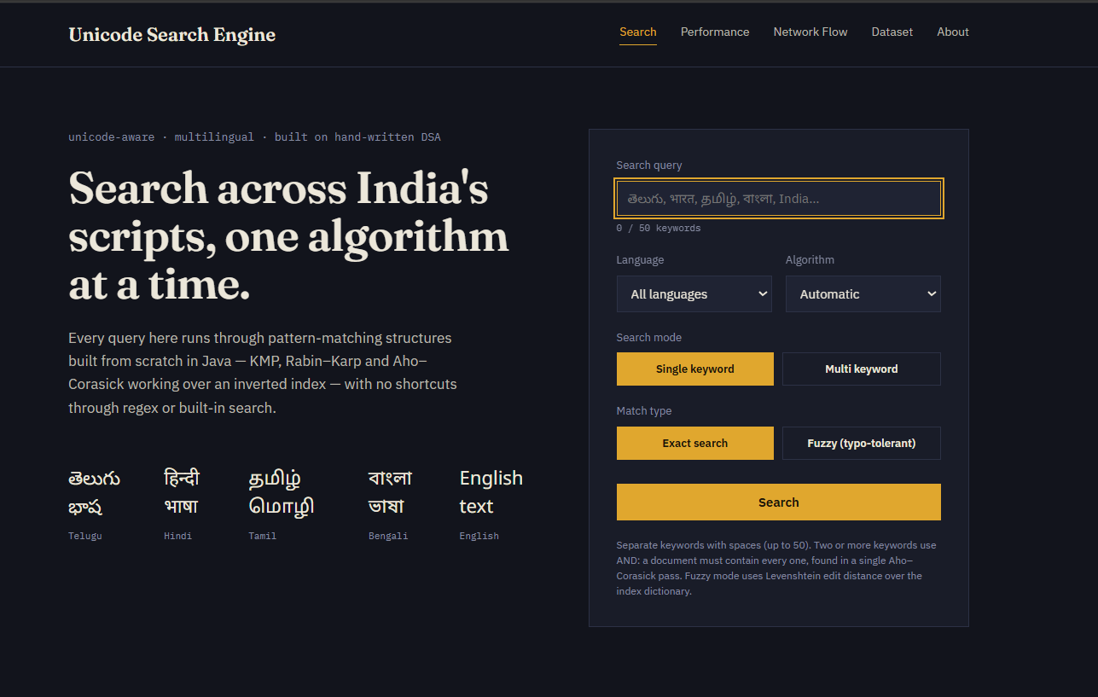
Explanation:
The main interface allows the user to enter a Unicode keyword or pattern for searching. The system accepts multilingual input and processes the query using the implemented searching techniques.

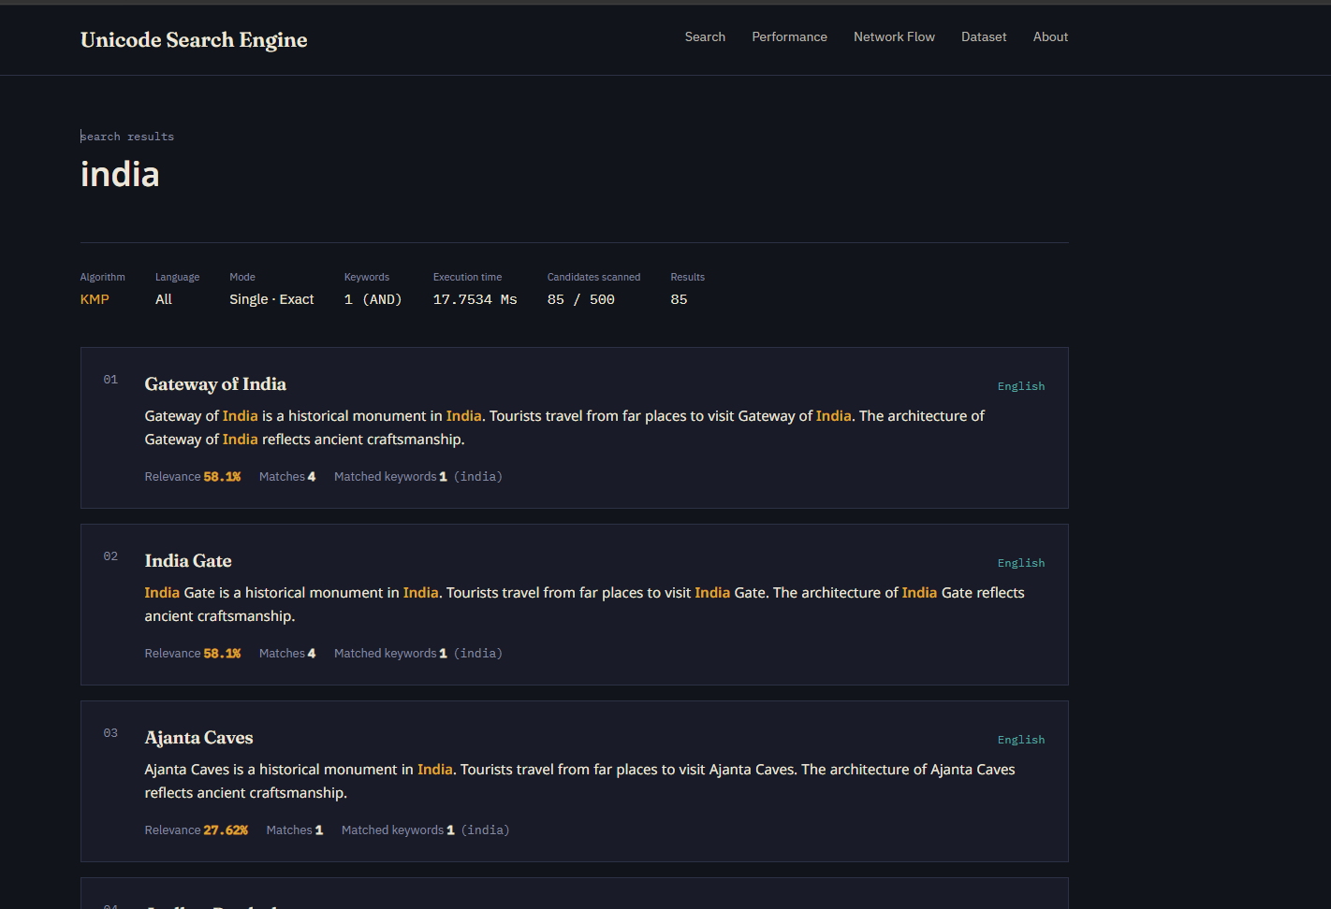
Explanation:
The system displays documents containing the searched Unicode pattern. Matching information and relevant context are provided to help the user identify the required content.
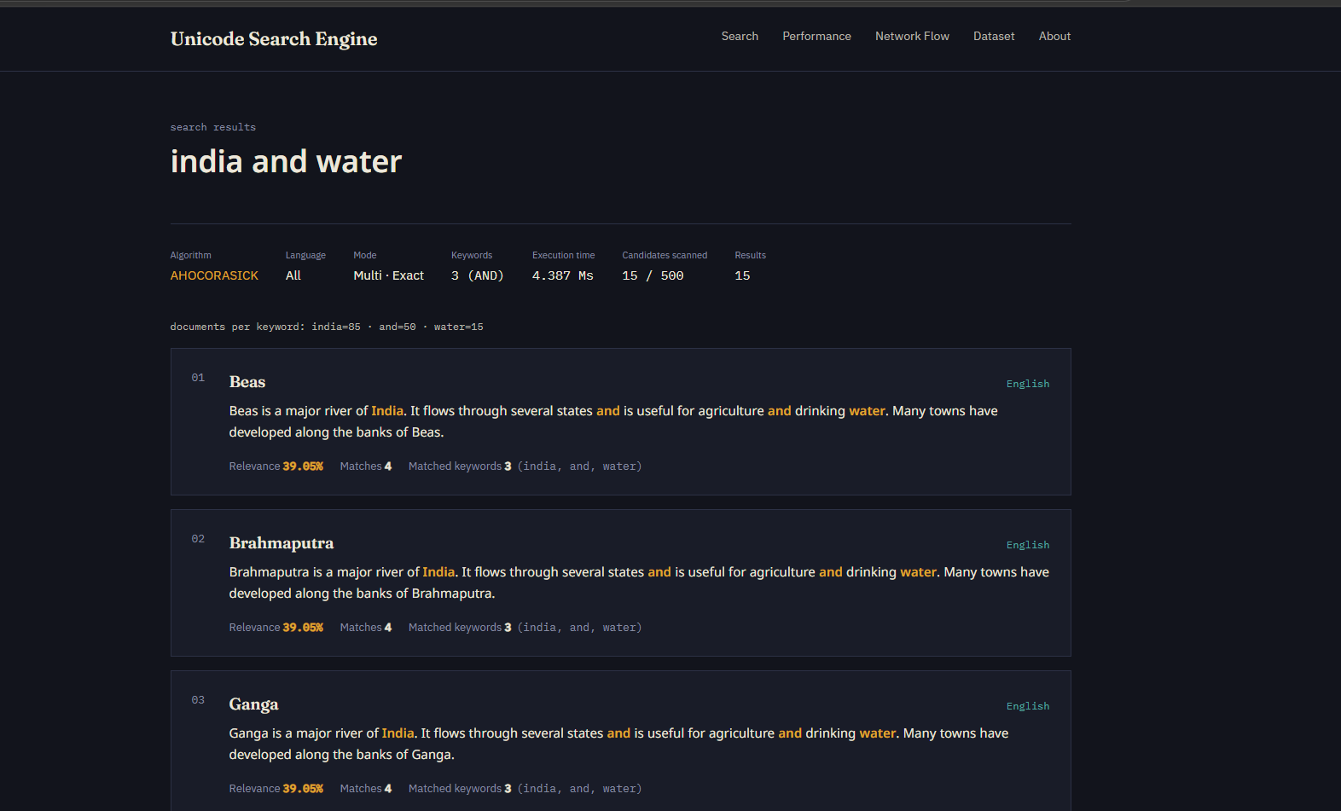
Explanation:
The Aho-Corasick based search can identify multiple keywords efficiently in the text, reducing the need for separate searches for each pattern.

8.CONCLUSION & FUTURE SCOPE
conclusion
The Unicode Pattern Search Engine for Indian Wikipedia demonstrates how Data Structures and Algorithms can be applied to solve the problem of multilingual text searching. The project combines Unicode-aware preprocessing with efficient pattern matching algorithms to support searching across Indian-language Wikipedia content.
The implementation of KMP, Rabin-Karp, and Aho-Corasick provides different approaches for single and multiple pattern searching. The inverted index reduces the amount of text that must be scanned, while hash tables provide efficient keyword lookup and frequency processing.
The system addresses the challenges associated with large multilingual datasets and Unicode scripts. It provides a foundation for efficient information retrieval and can be further improved to support larger datasets and more advanced search functionality.
This conclusion is aligned with your project's stated conclusion that combining Unicode processing, KMP, Rabin-Karp, Aho-Corasick, inverted indexing and hash tables makes the system suitable for multilingual information retrieval.
Future Scope
Short-Term
- Improve Unicode normalization.
- Support additional Indian languages.
- Improve search-result presentation.
- Add more efficient query processing.
Medium-Term
- Implement TF-IDF based ranking.
- Implement BM25 ranking.
- Develop a complete web-based search interface.
- Improve contextual snippets.
Long-Term
- Support very large Wikipedia datasets.
- Implement distributed processing.
- Improve multilingual information retrieval.
- Add advanced relevance ranking and search features.

- REFERENCES
- • Wikipedia – https://www.wikipedia.org/
- • Telugu Wikipedia – https://te.wikipedia.org/
- • Hindi Wikipedia – https://hi.wikipedia.org/
- • Tamil Wikipedia – https://ta.wikipedia.org/
- • Bengali Wikipedia – https://bn.wikipedia.org/
- • Unicode Consortium – https://www.unicode.org/
- • Apache Lucene – https://lucene.apache.org/
- • Elasticsearch – https://www.elastic.co/elasticsearch
- • Stanford Introduction to Information Retrieval – https://nlp.stanford.edu/IR-book/
- • GeeksforGeeks – Pattern Searching – https://www.geeksforgeeks.org/

